

Mechanical Group Progress Report

A Report Made By Alex, Rosani and Sean

Contents

Introduction 3

Alex’s Contribution to the Mechanical Team 3

NSK Ball Screws, What are they? 3

Organizing Mechanical Group 4

Tool Post Carriage CAD Drawing 5

Tool Post Tool Holders CAD 5

Conclusion 5

# Introduction

Our primary goal for the Semester 1 was to automate a ***Colchester Student 1800 Lathe*** that was originally completely mechanical. To complete this we decided that it was best to separate into three different groups and work on individual components rather than working on different things all together. Our groups consisted of Mechanical, Electrical and Control, they all have their own goals and objectives that needed to be completed. Being In the Mechanical Group we were tasked with: Identifying the Ball Screws of the X and Y axis, Identifying the Lathe Components

# Alex’s Contribution to the Mechanical Team

My Contribution to the Mechanical Team consisted of:

* NSK Balls Screws What are they?
* Tool Post Carriage CAD Drawing
* Tool Post Holders CAD Drawing
* Slightly Organizing our Mechanical Group.

## NSK Ball Screws, What are they?

I’ve done some small research / information on how ball screws are and how they work. Their Function and their design.

*A Ball Screw is a mechanical linear actuator that translates rotation motion into a linear motion. To put it into perspective it’s essentially a rod that moves within a thread that spins and due to this rotational movement it can either move forward or backwards. With this in mind it’s important to note that due to this design there is very little friction due to the use of ball bearings hence the name Ball Screws. Due to this ball bearing design the tolerances are very little and can achieve situations that require very high precision. It is also an enclosed system that is self-lubricated, however needs to be serviced once in a while.*

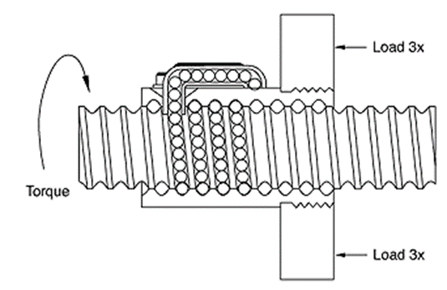

I’ve also included some of the equations that can be used to calculate the following:

$$T=\frac{Fl}{2πv}$$

*T= Torque applied to Screw or Nut*

*F= Linear Force Applied*

*l= Ball Screw Lead*

*v= Ball Screw Efficiency*

## Organizing Mechanical Group

I have contributed by helping both of my team members in doing work while also organizing them to their own specific things. This includes a small list of things that we wanted to accomplish Rosani and Sean being part of my group I helped them out with any enquires that they had.

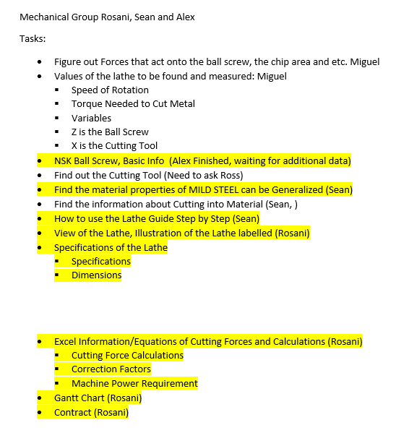

While having a small list I believe that I have contributed to this task and managed to organize our group accordingly.

## Tool Post Top Carriage CAD

The Tool Post consisted of multiple of different parts that were integrated into one. I’ve separated these drawings and drew them separately.

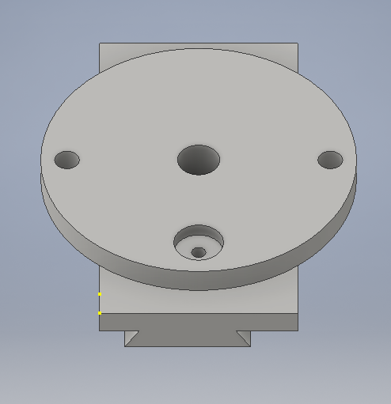Here is what they looked like:

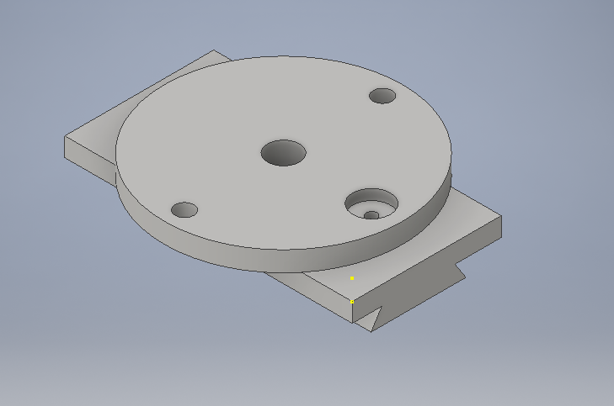

One of the biggest challenges with this particular drawing was figuring out the small little bits like measuring inside diameters that cannot be accused by a normal ruler or a Vernier because of the uneasy access. Also relating different measurements to their counter parts. Having this tool bit into two parts which made things a little easier.

## Tool Post Bottom Carriage CAD

This particular drawing wasn’t as hard to do but it still had its complications. For example this particular Tool Holder had a mechanism that I wasn’t able to replicate. Hence it just has a parts that’s not 100% functional.

Here is what it looks like:

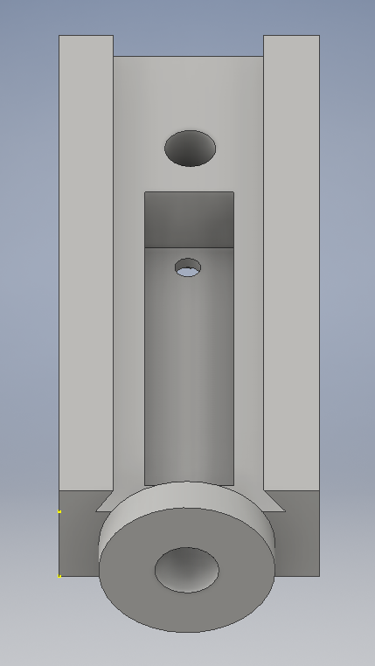

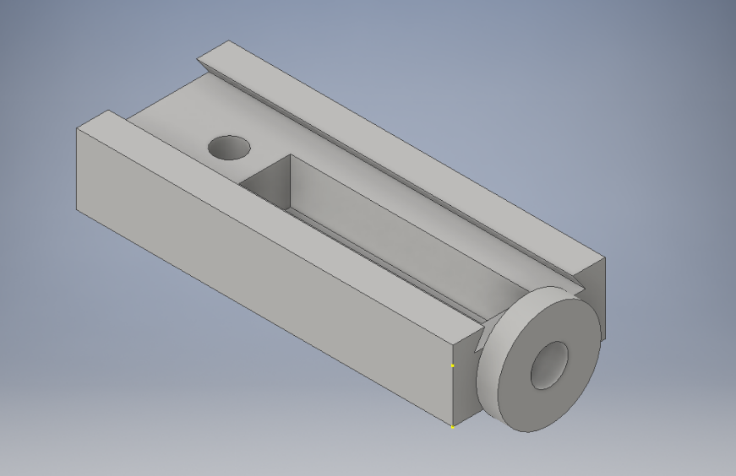

# Conclusion

In conclusion we have worked quite effectively during the 8 weeks that have elapsed. We were able to achieve quite a lot given that we had little to nothing to go off. However it does feel that we could have accomplished a little bit more during this small time period if we had a little more guidance. I hope that we can achieve a lot more in the upcoming Term 2.